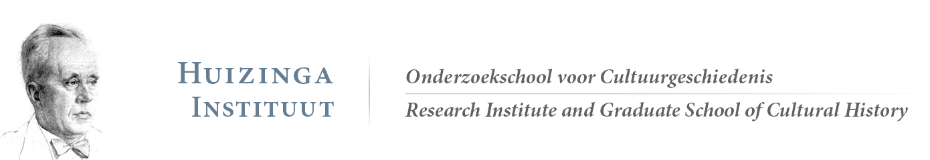
Application form for activities and/or financial support
The Huizinga Institute welcomes you to submit proposals for different kinds of activities. Please send the filled out form to the Huizinga office (huizinga@uu.nl). We will then contact you

Type of event
- Education (e.g. masterclass, workshop, atelier, lecture, debate, symposium, or course)
- Community building and co-operation in cultural history
- Other (please specify):

Names of the organizers and if applicable their supervisors
…
Brief description of the event (Topic, speaker(s), relationship with Huizinga Institute, (in case of ECTS) name of responsible teacher) – max. 200 words.
…
Learning outcome
…
Indicative programme/schedule
…
Preparation and proposed readings in case of educational activities (Preparation: e.g. abstract, presentation, review, etc. Please provide clear conditions for obtaining ECTS – Literature: Please provide the complete title information. PDFs are to be sent to the Huizinga Institute in advance).
…
Event details
Title:
Date:
Time:
Venue:
Coordination:
No. of ECTS Credits:
Open to (ReMa students and/or PhD candidates):
Maximum no. of participants in this event:
How to register (standard via the Huizinga Institute):
Registration deadline:

Budget (Please indicate the expected costs, broken down per post, e.g. catering, venue, travel)

…

The Huizinga Institute finds it important to strengthen the global dimension of cultural history in our programme. We ask you to, if possible, assimilate a global aspect in your proposal.
We invite you to include recent literature and diversity in literature.
Certificates of participation will be issued by the Huizinga Institute after the event. Event coordinators will decide whether the participant has fulfilled all requirements for the ECTS.

