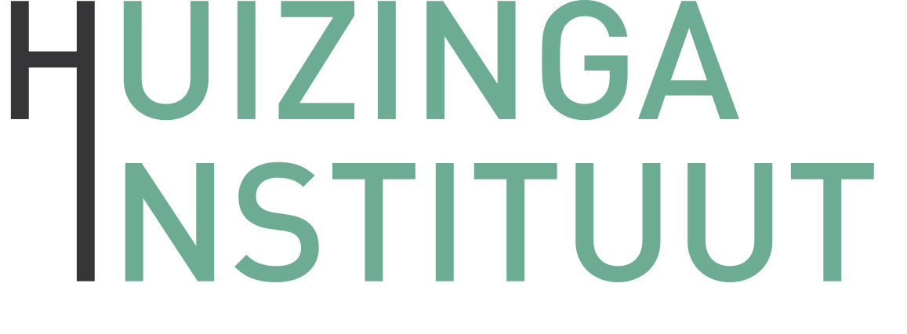
Application form for activities and/or financial support
The Huizinga Institute welcomes you to submit proposals for different kinds of activities. Please send the filled out form to the Huizinga office (huizinga@uu.nl). We will then contact you

Type of event*
- Education (e.g. masterclass, workshop, lecture, debate, roundtable, symposium, or course)
- Community building and co-operation in cultural history
- Other (please specify):

Names of the organizers and if applicable their supervisors
…
Event details
Title:
Date:
Time:
Venue:
Coordination:
No. of ECTS Credits:
Open to (ReMa students and/or PhD candidates):
Maximum no. of participants in this event:
How to register (standard via the Huizinga Institute):
Registration deadline:

Brief description of the event (Topic, speaker(s), relationship with Huizinga Institute, (in case of ECTS) name of responsible teacher) – max. 200 words.
…
Indicative programme/schedule
…
Learning outcome
…
Preparation and proposed readings in case of educational activities (Preparation: e.g. abstract, presentation, review, etc. Please provide clear conditions for obtaining ECTS – Literature: Please provide the complete title information. PDFs are to be sent to the Huizinga Institute in advance).
…

Budget (Please indicate the expected costs, broken down per post, e.g. catering, venue, travel)

…

* The Huizinga Institute uses the following event types:
Masterclass: A top-down lecture, followed by a short Q&A imparted by a leading expert on the field that Huizinga members would not have regular contact with, often a researcher from a foreign institution. Participants could be selected on the basis of the relevance for their own research topic. ca. 10-15 participants.
Workshop: Interactive setting with the organizer taking the lead. Possible preparation (reading several articles). Collaborating on the spot. ca. 15-20 participants. Selection of participants is preferential on the basis of relevance to their research.
Roundtable (Rondetafel): Several expert researchers (3-6) sharing opinions about the state of research and new directions in a subfield of cultural history (or cultural history proper). After the discussion, a longer Q&A with the audience ensues. ca. 20-25 participants.
Thematic course: Series of sessions, spread over time, led by a specialist on the field. This can be a combination of masterclasses and workshops. ca. 15 participants.

Certificates of participation will be issued by the Huizinga Institute after the event. Event coordinators will decide whether the participant has fulfilled all requirements for the ECTS.
The Huizinga Institute aims to extend its focus on the global dimensions of cultural history and encourages you to integrate such a perspective, where possible, in your teaching activities.
We invite you to include recent literature and diversity in literature.

